WELCOME

TO WEB DESIGN

1

**CHAPTER 1**

HTML Part 1 Evaluation

**CHAPTER 2**

**June September October**

# ENCODING

**19 Weeks** INFORMATION

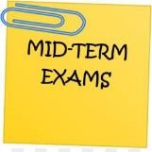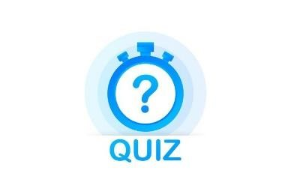

**15% 10% 25% 50%**

2

## OBJECTIVES FOR TODAY

* **Why** do we create web pages ?
* What is a **web page** and what is the **HTML** file ?
* How to display a HTML file on **browser** ?

### WARM UP



10 MIN TEAM 2 FREE DISCUSSION

|  |  |
| --- | --- |
| Select 1 of those web site | Answer those questions |
| <https://www.w3schools.com/> | 1. What do you think about these web sites ? 2. How do you feel about these web sites ? |

<https://www.amazon.com/>3. Why companies always have a website ?

4. What do you expect of a website ?

[https://www.unicef.org/cambodia/educa tion](https://www.unicef.org/cambodia/education)

**What is a programming language ?**



5

MIN

CLASS



Khmer

Khmer



English

Student

Student

Student

Teacher

English

**What is a programming language ?**

Browser



Student

HTML

HTML



5

MIN



CLASS



Programming

language

Student

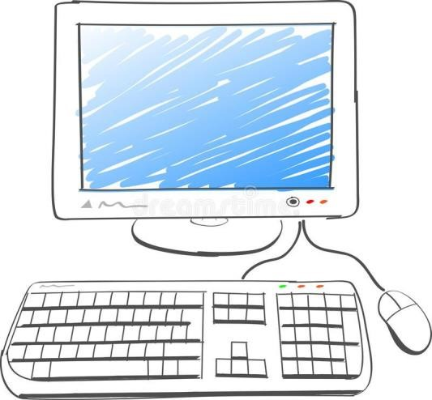

Programming

language

Computer

5 MIN CLASS 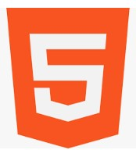



**HTML is the language to create web pages**

**H**yper**T**ext **M**arkup **L**anguage.

You can make links HTML language from one page to Is based on TAGS another

EXPLORATION  **You first web page**



15 MIN 1

* Open VSCode
* Create a file **page.html** with following content :

|  |
| --- |
| <**html**>  <**head**>  <**title**>HTML lesson 1</**title**>  </**head**> <**body**>  <**h1**>My first page</**h1**>  <**p**>Hello WEP 2023 students!</**p**> </**body**>  </**html**> |

* Open this file on your web browser.

### EXPLORATION

**You first web page**



15 MIN 1

* Compare your code with the result on the browser and answer questions:
  + Where is the *content* of : <**title**>, <**h1**>, <**p**> ?
  + What is the *meaning* of : <**title**>, <**h1**>, <**p**> ?
* Check on Google :
  + What is **HTML language** ?
  + What does **HTML** *means* ?

### EXPLAIN

5 MIN CLASS **What is a HTML TAG ?**



<

**title**

>

HTML lesson 1

<

/

**title**

>

Start tag End tag

Tags tell the **browser** about the **structure** of your **HTML**

### PRACTICE

**Draw the final result on your book**



10 MIN 1

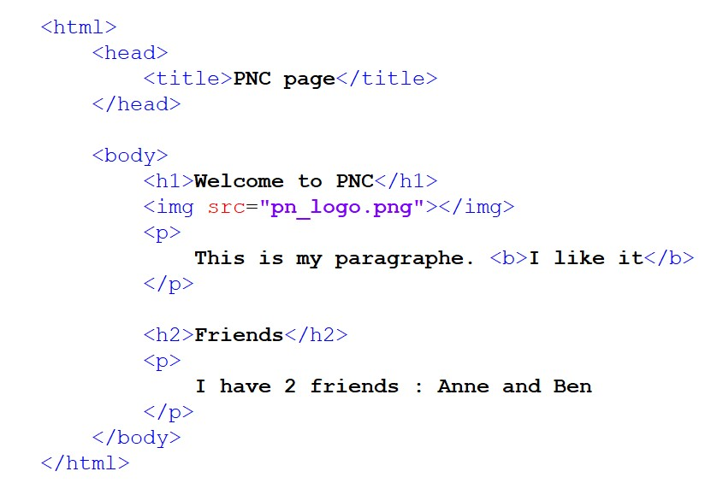

DISCUSS

 **What is the meaning of each tag?**

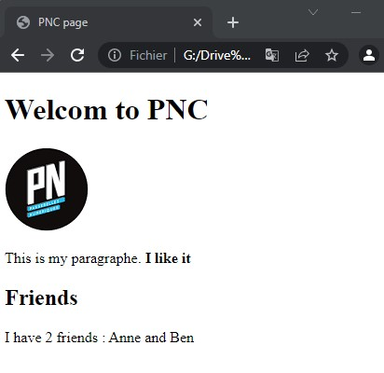

1

2

3

4

5

CLASS

1

2

3

4

5

### HOMEWORK



INDIV

### **After class**

1. Complete the **handout** I give you now.
2. Do the required **homework**
3. Send your homework to **Google Classroom**